Coaches/Managers.
Thank you for participating in our U11 girls end of the year tournament. This tournament is meant to be all about the girls, putting smiles on there faces and making memories.
For this tournament, you don’t need to bring any soccer balls, tents, or benches as we will provide them.
We have a lot of games to play within the two days, including and all-star skills competition. We have reduced all games to 25 mins a half. Teams are welcomed to warm up behind the far end net prior to their games. All games will start at their designated time.
As you will see there is a time slot to obtain a group photo of all the players and teams together. I encourage all teams participate in this photo.
There will be porta potties available at the field along with a small canteen.
The all-star event will take place at the end of day one. All players will have the opportunity to participate. The goal for this tournament was to bring the players together. Once your team provides of list of players for each event, they will be mixed in with other teams. For example: for team relay, their will be a player from Grand Falls, Hampton, WV and FDSA.

Thanks,
Chris

Tournament Rules for the Western Valley U11 games
1. All participating teams must be currently registered with Soccer New Brunswick. Participating teams must complete and submit by the stated deadline, the team by stated deadline. The Tournament Committee and Western Valley Soccer Association.
2. Upon arrival at the Tournament, each team shall provide the name and telephone number of the team representative to Tournament Registration so contact may be made by Tournament Officials in the event conditions require it. Teams shall ensure that the point-of-contact information provided is for a team official that is reasonably accessible during non-game hours.
3. Weather
During the round-robin series, as a result of deteriorating weather conditions, the Tournament Committee reserves the right to shorten the length of any game in an effort to ensure that all games are played. Further, if necessary, the committee may cancel any game which does not have a bearing on the final standings of any group, as a result of these adverse weather conditions. Should a game in progress be terminated due to weather conditions after the first half of play has been completed, the game shall be considered complete and the score at termination shall stand. If a game is suspended prior to the completion of one half, the Tournament Committee may reschedule the game or may cancel the game and use shoot-out procedures to determine a winner. Teams are responsible for checking with the Tournament Committee for rescheduling information. Lightning: When the Tournament Committee sees lightning, everyone is to leave the fields. A count will then begin from the time you see lightning counting down from thirty (30) minutes. Each flash of lightning will cause the timer to be reset.
4. All teams should be at the field and ready to play 30 minutes before the scheduled game time. A team official will check in with the registration desk or field marshal at least 30 minutes prior to the start of a scheduled game indicating the team is present.
6. Forfeits, If a team is unable to field six (6) players for U11, at the scheduled start time, the game may be forfeited. At the discretion of the Tournament Committee, a shortened game or shoot-out may be substituted for the match. Teams must remain at the site until a decision is reached. If a forfeit is declared, the team ready to play shall be declared the winner and a score of 1-0 will be recorded. No team will be allowed to gain an advantage through defaulting a game nor shall the team that does appear be disadvantaged.
7. Tournament Standings.
a. Teams will be randomly assigned to sections for round-robin play. The round-robin standings shall be determined by utilizing the following criteria: Win: 3 points Tie: 1 point Loss: 0 points
b. If, at the end of the round-robin series, there is a tie, the higher placed team will be identified according to the following criteria in order:
i. Fewest goals allowed
ii. Goal differential that is determined by subtracting the total goals allowed (not to exceed 5 in any given match) from the total goals scored (not to exceed 5 in any given match)
ii. Winner of head-to-head competition (not to be used for more than a 2-way tie)
8. Game play rules.
i. Play on intermediate size fields with an 8v8 format. Off-side rules will be in effect
9. Substitutions Unlimited substitutions shall be allowed according to current Soccer New Brunswick regulations. All substitutions are permitted at the discretion of the referee.
10. Player Equipment.
It is the responsibility of all teams to bring their primary uniforms and alternate strip or pinnies. In the event of a conflict of Jersey colours, the AWAY TEAM listed on the schedule shall be required to change. The Keeper's Jersey shall be distinct from those of his/her teammates, the opposing team and the referee. All players must wear shoes which conform to the requirements of FIFA Law IV. Shin guards are mandatory.
11. Officials
A referee will be assigned for all games in the tournament.
11. Duration of games
All round-robin and crossover games will consist of two (2) halves of twenty five (25) minutes. Each team is guaranteed a minimum of four (4) games. In all games, each team shall be entitled to a five (5) minute rest period at half time. Should any of the medal games end in a tie, the teams shall change ends and play two (2) halves of five (5) minutes duration, with the Golden Goal rule in effect. At the end of the first five (5) minute period, the teams shall change ends and proceed with the second half without a break. If, at the end of the two (2) overtime periods, the game is still tied, the game shall be decided by penalty kicks taken in accordance with the regulations laid out by the FIFA Laws of the Game. Should field time, weather or field conditions warrant, the referee and Tournament Committee may eliminate overtime and go directly to penalty kicks.
12. CAUTIONS/EJECTIONS
a) Cautions - If a player or a team official receives two (2) cautions during a game there will be a one (1) game suspension. If a player receives three (3) yellow cards within the Tournament, the player is disqualified from the remainder of the tournament. b) Ejections - If a player or a team official is ejected from a game, an automatic one (1) game suspension shall be invoked against the offending individual. The suspension will be in effect during that team's next scheduled game. The Tournament Committee reserves the right to impose a longer suspension if deemed necessary. A player who receives two (2) red cards will be disqualified from the Tournament.
ALL EJECTIONS WILL BE ACCOMPANIED BY A WRITTEN REPORT SENT TO THE APPROPRIATE CLUB, DISTRICT AND PROVINCIAL ASSOCIATION. IN THE EVENT SOCCER NEW BRUNSWICK ENACTS REGULATIONS CONTRARY TO THESE PRIOR TO THE TOURNAMENT, SOCCER NEW BRUNSWICK RULES WILLTAKE PRECEDENCE. Teams are responsible to ensure players sit out any games they are suspended for.
13. CONDUCT OF TOURNAMENT The referee's decision in matters concerning the application of the rules of the game and the decision of the Tournament Committee regarding conduct of the tournament shall be final. The Tournament Committee relies heavily upon coaches to set a positive example of conduct and sportsmanship and to exercise the necessary control over their players and associated parents and spectators.
Teams
Western Valley
Grand Falls
FDSA
Charlotte County
Hampton
Miramichi
September 9
Time Away Team Vs. Home Team
9-10 WV Vs. FDSA
10-11 Grand Falls Vs. Miramichi
11-12 Hampton Vs. Charlotte County
12-1 WV Vs. Miramichi
1-2 Grand Falls Vs. Charlotte County
2-3 FDSA Vs. Hampton
3-4 Miramichi Vs. Charlotte County
4-5 Grand Falls Vs. FDSA
5-6 WV Vs. Hampton
6:15 Group Photo
6:30 All Star Competition
September 10
Time Away Team Vs. Home Team
9-10 WV Vs. Charlotte County
10-11 Miramichi Vs. FDSA
11-12 Grand Falls Vs. Hampton
12-1 Charlotte County Vs. FDSA
1-2 WV Vs. Grand Falls
2-3 Miramichi Vs. Hampton
4-5 Top 2 teams play for Championship!

All Star Events
Players can only participate in one event.
Hardest shot
Each team will submit 4-5 players to participate
Each player will have 3 attempts to kick a soccer.
The players hardest kick, will be used to determine winner>
Top 3 players will receive a reward.
Team relay
Each team will submit a roster for players to participate
Each team will be placed against another team in a relay. The winner will move on.
Players will dribble the ball around a cone, half way across the field and come back and make a pass to the next player in line
Top 3 teams will receive an award
FDSA vs Saint John
Grand Falls Vs Miramichi
Chaleur Vs Fundy
WV Vs Charlotte County
Penalty kicks
Each team will submit 3 players along with a goalie.
Each team will have 4 kickers, winning team will continue on.
If the score is tied after 4 shooters, sudden shootout will take place.
Grand Falls Vs. FDSA
Chaleur Vs. Charlotte County
Miramichi Vs. Saint John
WV Vs, Fundy

Team Name: _________________________
Hardest Shot
Jersey # Name
______ ______________________________
______ ______________________________
______ ______________________________
______ ______________________________
______ ______________________________
______ ______________________________

Team Relay
Jersey # Name
______ ______________________________
______ ______________________________
______ ______________________________
______ ______________________________
______ ______________________________
______ ______________________________

Penalty Shot
Jersey # Name
______ ______________________________
______ ______________________________
______ ______________________________
Goalie
Jersey # Name
______ ______________________________

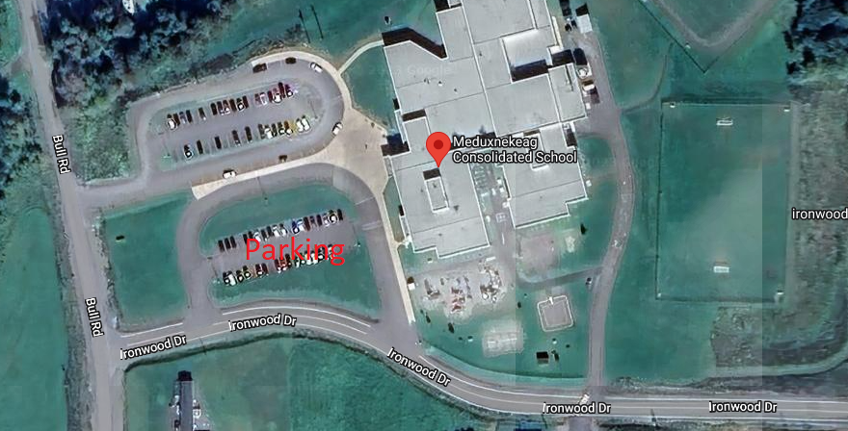
Parking for the games is available in front of the school, and is a small walk across the play ground.

